21. Sightly Syntax with examples

What Sightly offers?

1. Sightly comment.

2. Sightly expression

3. Sightly attributes

4. Sly element

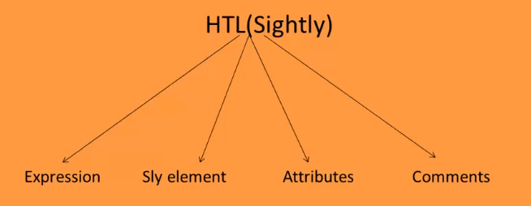

**Sightly comment:** Recommended over html comments. HTML comments will be rendered in final output (if we check the page source code, we will be able to see the HTML comments) but not the Sightly comments. So it’s recommended to use Sightly comments over HTML comments.

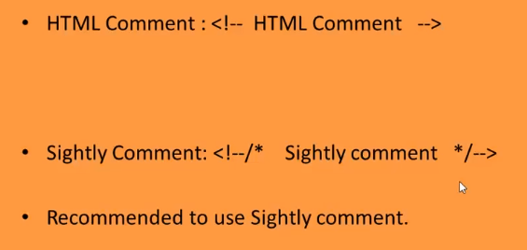

**Sightly expression:** ${}

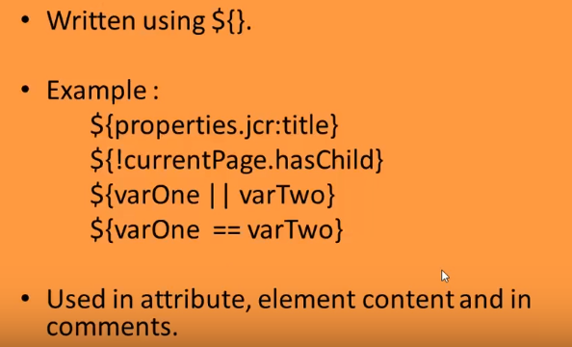

**Sightly attributes:** data-sly-use/call/repeat/text/list/test/include/resource.

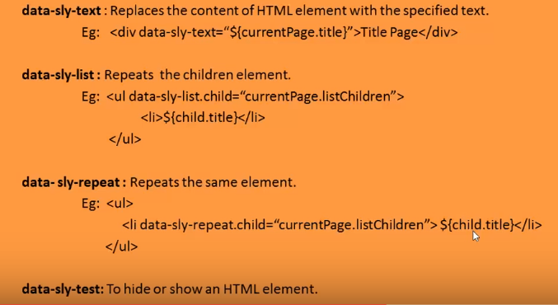

data-sly-text – When there is no value found in jcr, then the value specified with in the html tag (Title Page it the above example) will be displayed to the user else the value which is found in jcr get displayed.

**data-sly-test**

**Ex:** <div data-sly-test=”${wcmmode.edit}”>This is edit mode</div> (the text that is in between the markup will get displayed only if the authoring mode is edit.

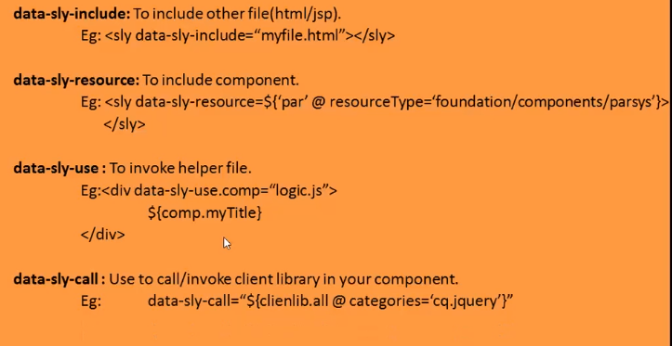

**Sly element:** It removes from the output.

